**DAILY ONLINE ACTIVITIES SUMMARY**

|  |  |  |  |  |  |  |  |
| --- | --- | --- | --- | --- | --- | --- | --- |
| **Date:** | **13/06/2020** | | | | **Name:** | **Varsha H Shetty** | |
| **Sem & Sec** | **8th B** | | | | **USN:** | **4AL16C117** | |
| Online Test Summary | | | | | | | |
| **Subject** | | **IOT** | | | | | |
| **Max. Marks** | | **30** | | **Score** | | **25** | |
| Certification Course Summary | | | | | | | |
| **Course** | **Introduction to Amazon API gateway** | | | | | | |
| **Certificate Provider** | | | **AWS certification** | **Duration** | | | **10 mins** |
| Coding Challenges | | | | | | | |
| **Problem Statement:** 1) Python Program to Display Calendar | | | | | | | |
| **Status: Solved** | | | | | | | |
| **Uploaded the report in Github** | | | | **YES** | | | |
| **If yes Repository name** | | | | **Varsha-Shetty** | | | |
| **Uploaded the report in slack** | | | | **YES** | | | |

Online test detail:

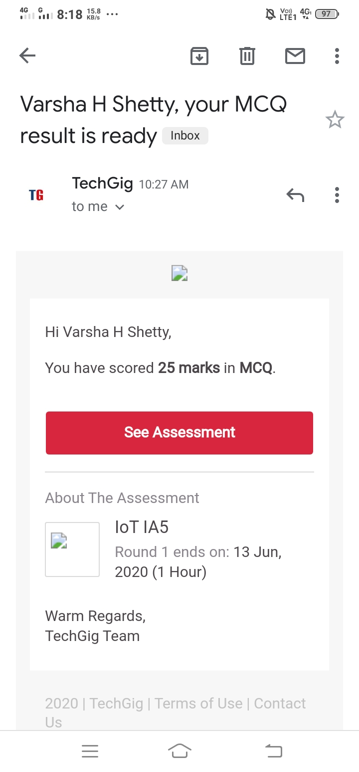

**Certification Course Details:**

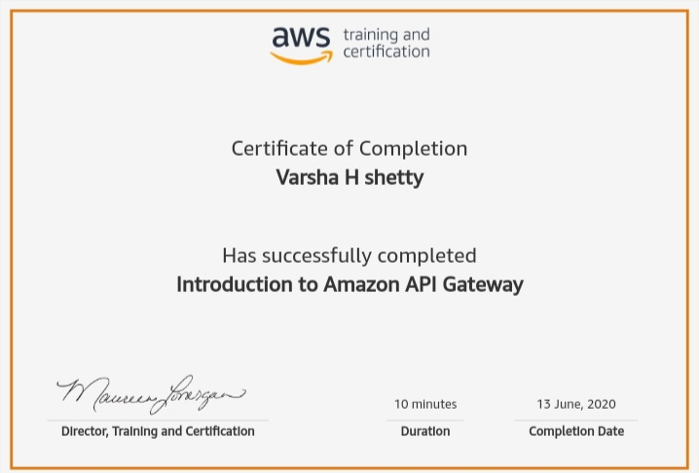

# CODE:

Program no:1

# importing calendar module

import calendar

yy = 2014 # year

mm = 11 # month

# To take month and year input from the user

# yy = int(input("Enter year: "))

# mm = int(input("Enter month: "))

# display the calendar

print(calendar.month(yy, mm))